Chemistry Project


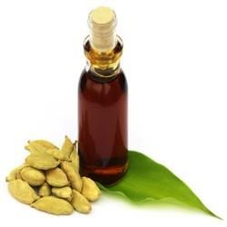

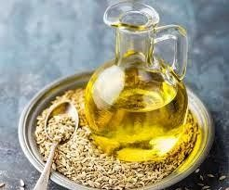


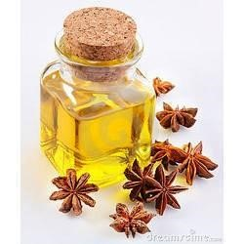

Extraction of Essential Oils Present in Aniseed(Saunf), Carum(Ajwain) and Cardamom(Elaichi)


NAME: TANISH SHARMA CLASS: XII SCIENCE SUBJECT: CHEMISTRY
SCHOOL – KV HIRANAGAR
CERTIFICATE

THIS IS TO CERTIFY THAT TANISH SHARMA OF CLASS XII HAS
SUCCESSFULLY COMPLETED CHEMISTRY PROJECT ON THE TOPIC
"EXTRACTION OF ESSENTIAL OILS PRESENT IN
ANISEED(SAUNF), CARUM (AJWAIN) AND CARDAMOM
(ELAICHI)" UNDER THE GUIDANCE OF SONIKA MA’AM
DURING THE ACADEMIC YEAR 2023-2024 AS PER THE GUIDELINES ISSUED BY CENTRALBOARD OF SECONDARY EDUCATION(CBSE).
TEACHER’S SIGNATURE PRINCIPAL SIGNATURE

ACKNOWLEDGEMENT
I would like to express my deepest appreciation to all those who have provided me with the opportunity to perform this project.
I would like to thank my Chemistry teacher Neha Rathore Madam, whose valuable guidance has helped me to complete the project.Her suggestions and instructions have served as a major contributor towards the successful outcome of this project.
I take this opportunity to thank our principal of school, Mr. B.A.Londhe Sir, who was always supportive and helpful in fulfilling all our academic requirements.
I would like to thank my parents for giving encouragement, enthusiasm and invaluable assistance to me.
Last but not the least; I would like to thank all my classmates who have supported me in various aspects.
1 | INTRODUCTION
2 | AIM
3 | USES
4 | EXPERIMENT
5 | PROCEDURE
6 | OBSERVATION
7 | RESULT

Table Of Contents
INTRODUCTION
An essential oil is a concentrated hydrophobic liquid containing volatile aroma compounds from plants. They are also known as volatile oils, ethereal oils, aetherolea etc. Essential oils are made up of highly volatile substances which can be extracted from numerous plant species. Distillation based recovery processes such as steam and vacuum distillation are preferred for the extraction of essential oils from plant materials. Virtually all naturally occurring essential oils are made up of hydrocarbons such as camphene, pinene, limonene, phellandrene, cedrene, and oxygenated hydrocarbons such as alcohols,aldehydes,esters,ketones,
Lactones,phenols and organic acids,The essential oil get their odours from the
Oxygenated compounds contained in them and these confer stability on the oil against oxidation.
The hydrocarbons are less stable and they are responsible for the degradation observed in the oils. The hydrocarbons contained in the essential oils are often removed so that the oils can be more stable and still retain their odours and flavours.
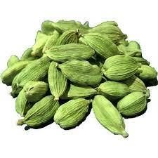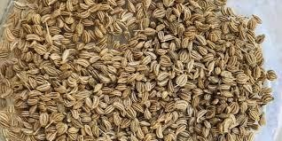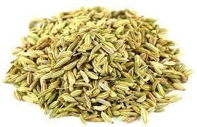

AIM

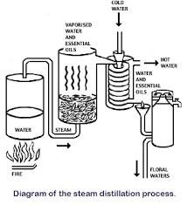

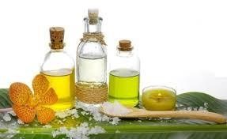
Extraction of essential oils present in
El
aichi
(
Cardamom
)
Saunf(Aniseed), Ajwain(Carcum) and
ANISEED OIL (SAUNF)
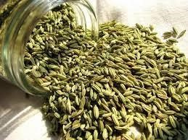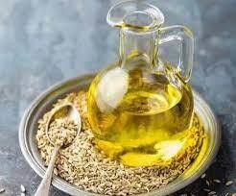
Botanical Name: Pimpinella anisum
Common Method of Extraction: Steam Distillation
Color: Clear
Aromatic Description:Distinctive scent of licorice. Rich and sweet.
Constituents: a-pinene, camphene, B-pinene, linalool, cisanethole, trans-anethole, safrole, anisaldehyde, acetoanisole.
USES:
- In aromatherapy, aniseed essential oil is used to treat colds and flu.
- Aniseed oil can be made into a liquid scent and is used for both hunting and fishing. It is put on fishing lures to attract fish.
- Anethole, the principal component of anise oil, is a precursor that can eventually produce 2,5dimethoxybenzaldehyde which is can be used in the clandestine synthesis of psychedelic drugs such as 2C-B, 2CI and DOB.
- Oil of aniseed is also reported to be used as an aromatic carminative to relieve flatulence, and as an ingredient of cough lozenges in combination with liquorice.


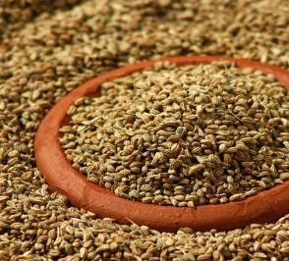

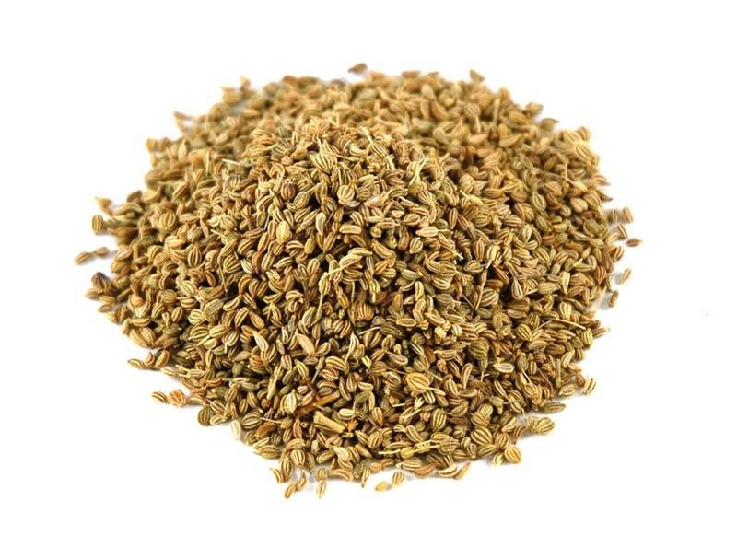

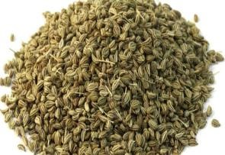
CAROM OIL(AJWAIN)
Botanical
name
:
Trachyspermum
ammi
Common
Method
of
Extraction
:
Distillation
Aroma: Warm, Pungent,Peppery
Extraction: Ajwain oil is extracted from the crushed seeds of ajwain by the method of
steam distillation.
Chemical composition:
The main constituents of the ajwain oil are thymol, gammaterpinene, p- cymene, and beta-pinene. Alpha-pinene, alpha-thujene,
beta-myrcene, carvacrol, limonene, and terpinene-4-ol.
10
There are variations in the composition of ajwain oils depending upon the region where it is cultivated.
For instance, ajwain oil collected from Southern India is rich in thymol.
Uses:
•Skin Ailments: Ajwain can help with pimples.
- Digestive Aid: One can treat indigestion, ulcers, and various other bacterial infections of the gut with ajwain seeds and essential oil.
- Aromatherapy: Useful in aromatherapy, ajwain oil offers calming sensations that relieves neuralgia and migraines.


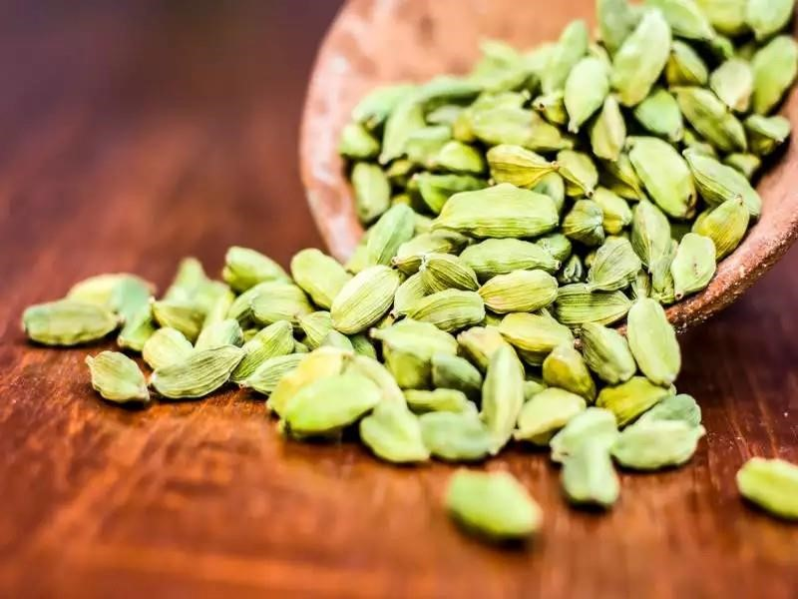

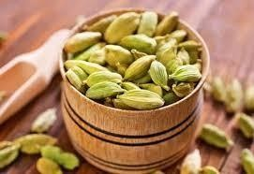

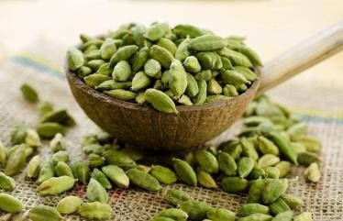
CARDAMOM OIL (ELAICHI)
Botanical
Name:
Elettaria
cardamonum
Common Method Of Extraction: Steam Distillation
Aroma: Very complex and smooth spice aroma
Extraction:
Cardamom oil is extracted using steam distillation method. For this, seeds of the fruit are used just before they ripe. The yield through this process is normally 1 to 5 per cent.
Chemical Composition:
Cardamom oil contains sabinene, myrcene, a-pinene, bpinene, a- phellandrene, limonene, p-cymene, terpinolene, 1,8cineole, y-terpinene, linalool, linalyl acetate, a-terpineol acetate, citronellol, nerol, terpinen-4-oil, a- terpineol, geraniol, methyl eugenol and trans-nerolidol.
Uses:
Cardamom oil has a vast range of usage for treatment of sciatica,coughs, abdominal pains, spasm and nervous disorders. Traditionally, it is used for pulmonary disease, fever, digestive and urinary problems in India and China for over 3000 years. It is also used to flavour pharmaceutical products. Apart from pharmaceutical usage, cardamom oil is also used as a fragrant in soaps, perfumes and cosmetic products.

EXPERIMENT
MaterialsRequired:
- Steam generator (Copper Vessel)
- Round bottom flask (500 ml),
- Conical flask
- Condenser
- Glass tubes
- Iron stand
- Sand bath
- Separatory funnel
- Tripod stands
- Burners
- Ajwain(Carum)
- Petroleum ether(60-80°C)
- Saunf(Aniseed)
Procedure:
1.Set the apparatus as shown in the picture of Experimental Setup. The apparatus consists of a steam generator connected to the round bottom flask through a glass inlet tube. The flask is connected to a water condenser through a glass outlet tube. Condenser is further attached to a receiver through an adaptor.
2.Take about 750ml of water in the steam generator and start heating to produce steam.
3.In the round bottom flask take about 75g of crushed saunf(aniseed).
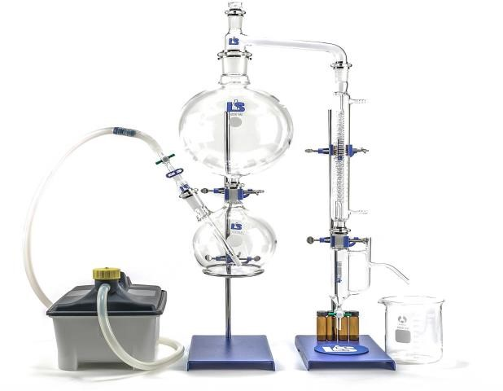
4.Avigorous current of steam from steam generator is passed through the round bottom
flask.
5.Apart of the steam condenses in the round bottom flask. As more and more steam is passed, the steam volatile components of saunf pass through
condenser along with steam. These contents on condensation are collected in the receiver.
6.The contents in the round bottom flask may be heated by a bunsen burner to prevent excessive condensation of steam.
7.The process of steam distillation is continued for about half an hour.
8.Transfer the distillate to a separating funnel and extract with 20ml portions of petroleum ether 3 times.
9.Combine the petroleum ether extracts in a 250ml conical flask and dry it with the help of anhydrous sodium sulphate.
10.Remove the solvent from the dried filtrate by careful distillation in a water bath. The essential oil is left behind in the distillation flask.
11.Find the weight of the extracted essential oil. Note the colour, odour and weight of the essential oil.
Observations:
1.Saunf(Aniseed):
- Weight of Saunf taken=100g Initial Weight of the bottle= 10g(x)
- Weight of bottle+essential oil= 11.25g(y)
Weight of essential extracted= (y-x)= 1.25g Percentage of essential
oil=(y/100)*100=1.25% Colour of the oil= Colourless
- Odour of the oil= saunf like smell
2. Ajwain(Carum):
- Weight of Saunf taken=75g
- Initial Weight of the bottle=10g(x)
- Weight of the bottle+essential oil=11g(y)
- Weight of essential oil extracted=(y-x)=1g
- Percentage of essential oil= (y/75)*100=1.33% Colour of the oil= Colourless
Odour of the oil= Ajwain like smell
RESULT:
Essential oils present in aniseed, carum and cardamom are extracted from this method.

